**This is just a simple manual, not the formal readme page**

1. Install WAMP(for Windows)/MAMP(for Mac). The download website is attached. Default configuration will be fine.

2. Copy the project’s repository to the in the WAMP/MAMP virtual server. The location of the project in the server is “…/WAMP/www/” (for WAMP) and “…/MAMP/www/” (for MAMP).

3. Start WAMP/MAMP and then type 127.0.0.1 in your explorer like below

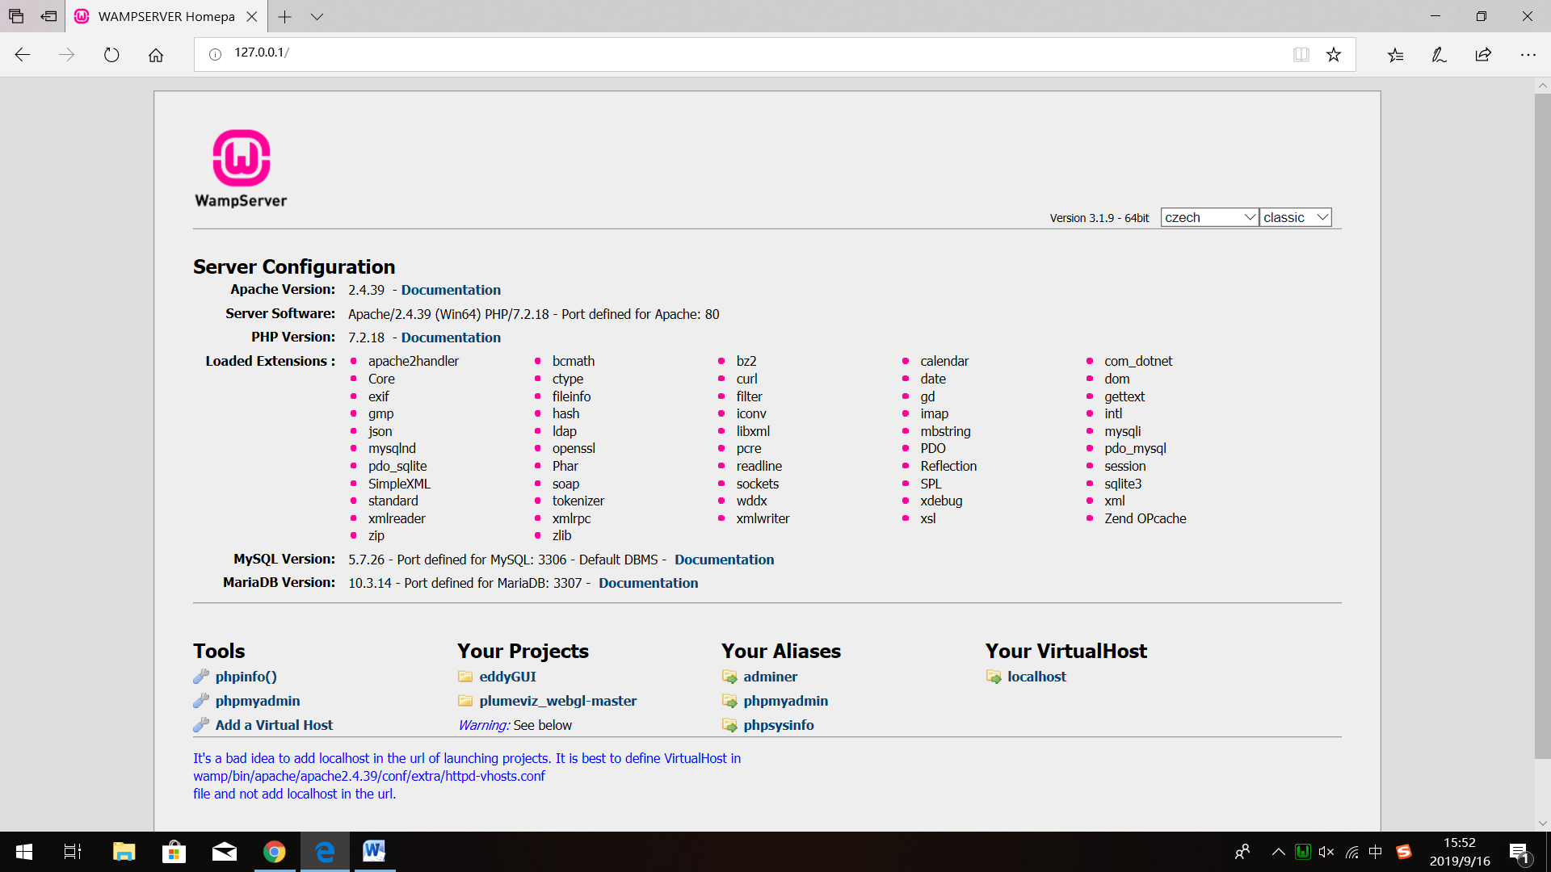

Notice that your virtual server has already turned green, which means it works well.

4. Choose the project you want to use. E.g. Plumevivz_webgl_master.

5.It works!

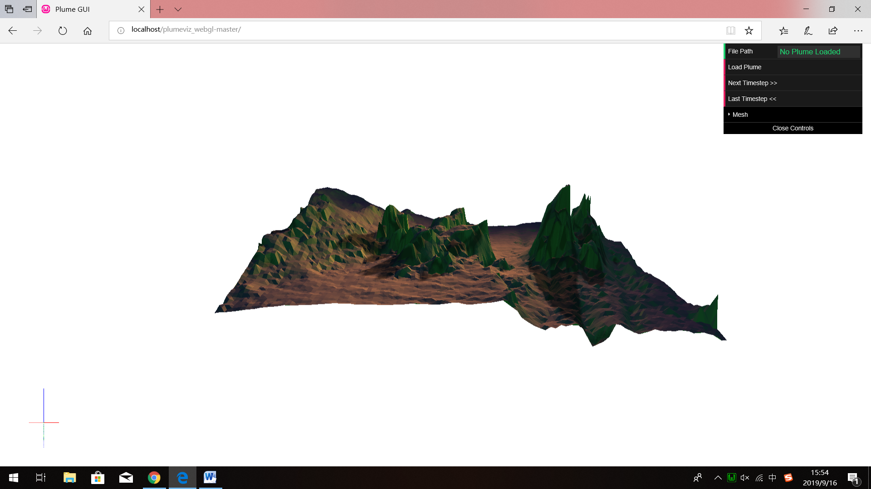

Download of WAMP: <http://www.wampserver.com/en/>

Download of MAMP: <https://www.mamp.info/en/> (You have to pay for MAMP Pro but not for MAMP)

The problem I met before is because that the file in Li’s project used a wrong address of repository. I think maybe he just copied files from an existing repository without changing address in the file, which had a different name of repository.